Item Response Theory (IRT)

[Rasch Logistic Model](https://www.sciencedirect.com/topics/social-sciences/rasch-model)

The Rasch model is a [mathematical function](https://www.sciencedirect.com/topics/mathematics/mathematical-function) that relates the [probability](https://www.sciencedirect.com/topics/mathematics/probability-theory) of a (correct) response on an item to characteristics of the person (one's ability) and to characteristics of the item (its difficulty).

Assumptions:

* First, the observed response (e.g., pass/yes/agree/right = l, rather than fail/no/disagree/wrong = 0) depends on the difference between only two parameters: the “ability” of the individual and the “difficulty” of the item. No extraneous factors should bias this linear relationship.
* Second, the parameters “ability” and “difficulty” are independent of each other. (It should be pointed out that the [invariance principle](https://www.sciencedirect.com/topics/mathematics/invariance-principle) is also a theoretical requirement for measurement in the field of physics.) In his “separability theorem,” Rasch showed that his measurement model is the only one that satisfies this requirement.
* Third, the model is probabilistic: uncertainty surrounds the expected response, a condition that is consistent with the real-world situation.

is the probability of a correct response to item .

Where:

* is the ability variable
* is the difficulty of an item

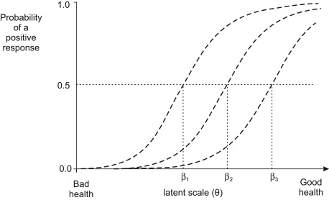

*[Darryl’s note] This model assumes mathematical latent scale as a continuum (like the image above) where the higher theta means higher mathematical proficiency, which does not match our goals of measuring conception. This is one motivating factor for developing a factor analysis where the answering of questions in certain ways (not right/wrong, but the choice of specific options in a question) predicts responses in future questions. We could also explore more than one parameter models.*

**One-Parameter Model**

To better estimate ability with the Rasch model, one can apply a coefficient to the exponents of the Rasch model and thus creates the one-parameter model. Consider modifying after running the model with .

is the probability of a correct response to item .

Where:

* is the ability variable
* is the difficulty of an item

[**Constructing a Rasch/1PL model**](https://real-statistics.com/reliability/item-response-theory/building-rasch-model/)

1. **Remove students with 100% scores and 0% scores**  
   Since we are taking log of average scores (either by student or by item), log(0) will produce errors.
2. **Approximate ability and difficulty**  
   Estimate ability per student with: , where  *(e.g., sum of 1s for a single student divided by number of items student answered)*Estimate difficulty per item with: , where *(e.g., sum of 1s by all students for a single question divided by number of students who answered the question)*
3. **Standardize difficulty for mean 0**Adjust difficulty per item with: *(e.g., adjusted difficulty is estimated difficulty subtracted by average difficulty of all items)*
4. **Iterate until sum of squares of residuals is sufficiently close to 0**  
   a*.* ***Calculate expected values:*** probability of student s answering question i correctly given a student’s ability score and the item’s difficulty   
   b. ***Re-calculate all and***  using the new expected values   
   c. ***Calculate estimated variances of expected values:*** d. ***Calculate residuals between estimates and original data****:*e. ***Calculate sum of squares of residuals***:   
   f. **If e > 0.0001, re-calculate expected values and repeat:** Calculate revised and and restart at step a.
5. **Calculate Standard Error**Standard error by student calculated as reciprocal of sum of estimated variance at end of iterations.
6. **Calculate Infit (information-weighted fit) and Outfit (outlier-sensitivity fit)**  
   a. ***Create fit table***   
   b. ***Create Outfit*** (average fit across students and across items) **GOAL < 1.3**  
   c. ***Create Infit*** *(sumsqs residuals / sum(variance))* **GOAL < 1.3**